**How an All-Inclusive Travel Planning Application Improves the Overall Trip Experience**

|  |  |  |  |  |  |
| --- | --- | --- | --- | --- | --- |
| **Andrew Leung** | **Jeffrey So** | **Caleb D’Souza** | **Gavin Leung** | **Brian Yang** | **Birathan Somasundaram** |
| leunga56 | sojeffr4 | dsouz229 | leungg10 | yangj148 | somasu22 |
| 1003289498 | 1003197104 | 1003205088 | 1003083138 | 1003483839 | 1003199175 |

**Abstract**

In this paper, we discuss the possible issues that could arise while planning a trip and propose a prototype with an interface designed to offer a user experience that solves these problems. The design of this prototype, which we named UTour, is based on data received from individuals that are both frequent travellers and those that travel not very often. This data was gathered through an online survey in order to provide insight on the travelling habits of potential users of our application. We then analyzed the participants’ willingness to use our application as well as took any suggestions that they might have had for the application's functionality. We came to the conclusion that users would like the ability to read or listen to details about a destination as well as read or write reviews for destinations all in one application in order to facilitate efficient trip planning. The prototype we created addresses this issue and we tested its effectiveness with individuals that fall within our target demographic - millennials aged 18 to 34 who actively use mobile devices. Lastly, we then describe the results and challenges that arose while conducting these tests and suggest potential solutions for designing a more intuitive and appealing interface in the future.

**Introduction**

According to recent 2018 travel trends cited by Facebook IQ, users are researching, planning, and booking more of their trips online and via their smartphones than through travel agencies (Facebook IQ, n.d.). A related study conducted by Google in 2016 showed that 70% of travellers who had a smartphone used their mobile devices to conduct their travel research and planning (Google, 2016). Additionally, a mobile trends report released by Travelport Digital in 2018 identified that 88% of travellers would prefer to access their favourite trip planning content all in one application to increase their efficiency and improve planning convenience (Travelport Digital, n.d.). Therefore, there is a high demand by travellers who actively use their smartphone devices as their daily drivers for a single application to encompass their travel research and planning needs.

Trip planning is an important factor for having a successful trip and smoother travelling experience. This is because a traveller’s plans impacts several aspects of their trip, such as how many activities they can successfully complete as well as their overall satisfaction of the trip. However, as of 2019 there is no single application that provides a robust research and planning experience for travellers to successfully plan their trips by efficiently and effectively gathering reviews about travel destinations and related activities.

Therefore, our proposed solution will accommodate the growing demand for a single mobile application where users have access to a digestible list of travel destinations and associated relatable and comprehensible reviews. Additionally, our solution will further meet travellers’ needs for more reviews by allowing users to effortlessly add their own reviews for travel destinations they have visited and would recommend to others.

**Literature Review**

In order to get a concrete idea of what problems to consider while in the preliminary stages of designing our prototype, we first decided to look at the results of a related international study.

In 2016, OECD performed technology proficiency tests on 215,942 adults across 33 countries by testing their technological aptitude in navigating a mock email website. They were each given 14 basic tasks to complete on the website with varying difficulties. Some of these tasks included using the reply-all feature and scheduling meetings using email messages. They were also given a level of proficiency from 1 to 4, based on how well the user performed their tasks. The results of the study showed that 70% of the participants ranked at or below level 2, where participants had difficulty with tasks involving multiple steps and inferential reasoning. It was concluded that the software-product team overestimated the aptitude of their users and made planning tools overly complicated and not user-flexible. In UTour, since it involves planning and browsing patterns similar to this emailing software, we studied some of the proposed solutions for the participants that had level 2 proficiency and under. These solutions included getting rid of extra information and clutter, as well as decreasing the amount of operations needed to complete a task (Nielsen, 2016). Since the goal of UTour is to make planning and organizing as easy and non-stressful as possible, we decided to follow the above principles while designing our prototype to ensure that as many users are satisfied as possible.

**Problem Statement**

There are many hassles travellers face when organizing and planning trips, as well as problems that can arise while touring destinations. For example, instead of a simple, straightforward option made available, users often have to go through multiple websites, applications, and blogs before finalizing a travel plan.

This leads us to consider the problem of trip planning efficiency. A 2013 study done by Expedia Media Solutions showed travellers would visit more than 38 websites on average to plan their trip (Schaal, 2013). Furthermore, a related 2016 study by TripAdvisor revealed that 74% of travellers planned their trip by first choosing a destination that is highly recommended by family, friends, and online reviews (TripAdvisor, n.d.). However, a 2016 study by Google suggested that 85% of travellers planned activities only after having arrived at their destination because they were not able to find reliable reviews or recommendations about activities online (Google, 2016).

Therefore, the main problem we decided to tackle is the need of an effective one-stop application where travellers can find reliable reviews on travel destinations and local activities to efficiently plan their trip.

**Gathering of User Requirements**

One of the easiest techniques for obtaining user requirements is by distributing a survey since it allows anyone to submit their answers without the need of supervision by an expert or interviewer. Thus, Google Forms was used to construct and distribute our surveys since this application also collects all response data into graphs for us which makes data analysis much simpler.

In our survey, we used a variety of question formats such as simple multiple choice questions, yes/no checkboxes, rating scales, and checkboxes that allow for the selection of multiple answers. We also included a few short open-ended response questions for the participants to describe their past travel experiences and to suggest extra features that they wanted to see included in the application. The survey had approximately two dozen participants with varying characteristics. Additionally, what we aimed for the most was having a somewhat even distribution in our participants between those that travelled often and those that did not. This was so we could get valuable feedback from frequent travellers while learning what hinders people from travelling.

From the survey we concluded that an overwhelming 83.3% (20/24) of participants would use customer reviews as a point of consideration before trying something new such as visiting restaurants or attractions. We also found that 62.5% (15/24) participants believed that being able to read or listen to details about the cities and attractions while on their travels would enhance their overall experience. With this in mind, we proceeded with implementing the Attractions and Reviews features into our prototype. The Attractions feature showcases the attraction that a user selects while the Reviews feature allows users to leave a review for an attraction that other users can read.

**Prototype**

In order to receive better feedback from potential users, we designed a prototype for UTour which simulates the three key features that users will most likely be interacting with before, during, and after their trip. The tasks that these features are able to accomplish includes *Creating a Travel Plan, Learning About a Destination,* and *Providing Feedback About Your Experience.*

*Creating a Travel Plan*

In order to create a travel plan, users will first be prompted to enter their tentative plans on when and generally where they plan to travel to. Users are then taken to their travel agenda which they fill in with their daily plans by adding destinations into the agenda’s time slots. Users will be able to conduct research on destinations in the application through searching or browsing the recommendations based on where they plan to go.

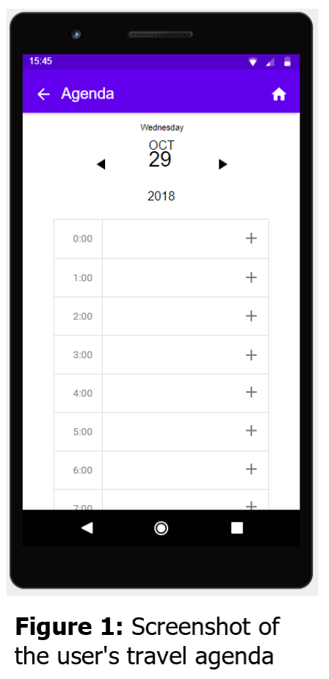

*Learning About a Destination*

When the user is at a destination at the time as planned in their agenda, which could be detected through the device’s location services, the user will receive a notification on their device which prompts them to learn more about this destination. When tapped, the user will be taken to the destination’s details page where they can see how well others have rated the attraction as well as explore the general vicinity around the attraction using the map. Lastly, there is a section of the page dedicated to a detailed description of the attraction which users have the option to read or listen to.

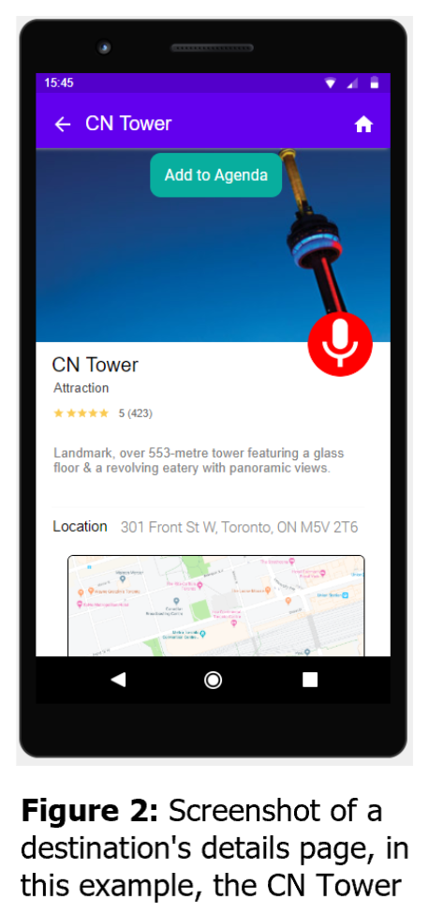

*Providing Feedback About Your Experience*

The main purpose of this feature is for users to help out future travellers when they are planning out their trips. Now after the user is done visiting a destination, they will receive another notification which asks them if they would like to leave some feedback about the attraction. Once the notification is tapped, the user will be brought to the ratings screen where they can leave a rating from one to five stars as well as write a review. Upon submission, the user will be brought to the reviews screen where they can see what others had to say about this attraction. Users may also tap the pictures tab on the bottom navigation bar to be brought to the pictures screen. This is where the user can see what the attraction looks like through pictures that other users have uploaded as well as upload their own.

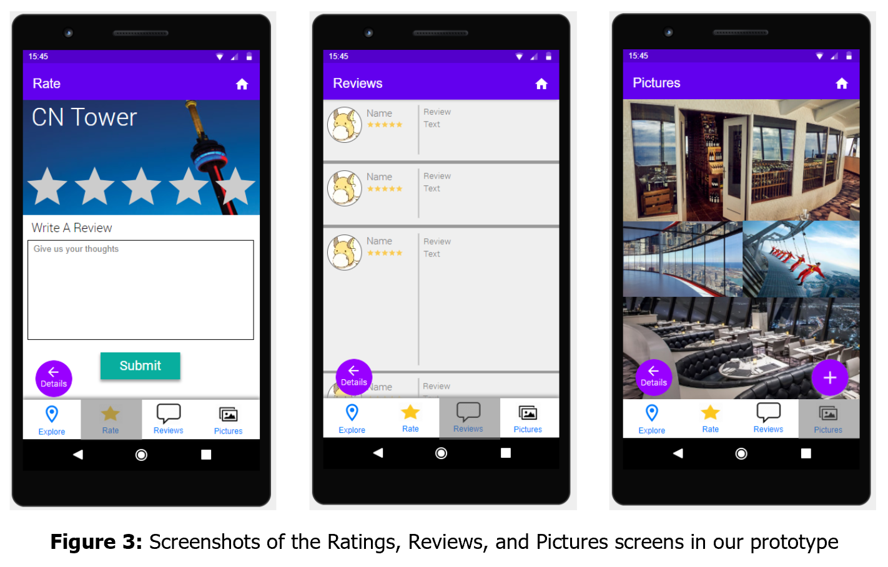

Overall, our prototype was designed with the intention for testers to feel like they are going through the whole process of planning a trip, going on the trip, and reflecting on their trip.

**Usability Study**

The method that was chosen for our usability study was a structured interview in a controlled setting which followed a test phase where participants utilized the prototype to complete a series of tasks. The study had six participants in total that were interviewed for various lengths of time, depending on the depth of the answers given. We decided to structure the interviews because they were one-on-one, allowing our interviewers to focus on getting the participant’s opinion on specific information about the prototype that we were interested in gathering data for.

The tasks we evaluated each participant on when using our high-fidelity prototype were:

1) Create a travel plan with a pre-determined attraction and time slot

2) Learn more about their trip and selected attractions as provided by the application

3) Simulate a post-visit scenario by leaving a rating and review, and upload pictures for the attraction the user just visited.

During the tasks, users were asked to think-aloud for transparency while the interviewer noted down their thoughts as well as observing the user’s actions to check for consistency. After the user completed the tasks given to them, the interviewer would then engage them in a one-on-one interview session by asking a series of questions focusing on the prototype’s functionality and the user’s overall experience and satisfaction with using our product.

The questions given to the participants in each interview were a combination of open-ended and closed-ended questions designed to receive quantitative data. Many of the closed-ended questions in the interview were paired with an open-ended question asking for the participants reasoning behind their choice in order to get a better understanding of what went well and what did not. For example, some of the questions were phrased to induce a yes or no answer and after receiving a response, the interviewer prompted the users to elaborate in order to provide deeper insight. As a result, we can get a clear consensus on the general preferences of our potential users while also understanding the reasoning behind their choices without any ambiguity that can skew data.

**Results**

*Creating a Travel Plan*

For most users, the premise of the functionality is very intuitive and easy to understand. Users also enjoyed how the data was displayed to them while choosing an attraction to add to their agenda. However, some users struggled to progress through the task without external guidance due to the layout of the pages related to this task. The placement of certain key elements were ambiguous, causing some of the participants to think they finished the task when in reality they missed a few crucial steps such as submitting the travel plan itself.

*Learning About a Destination*

In general, most participants were able to locate and use the functions in the informative menu, however, most participants reported that the microphone icon used to listen to the description of the attraction was misleading. One solution to this problem would be to change the microphone icon into a sound icon, to make it more apparent that it is a listening event.

*Providing Feedback About Your Experience*

All participants were able to navigate through the panels with ease and use most of the key functions on each panel. Additionally, one user in particular, although noticed the navigation bar at the bottom, was unaware that they had the freedom to alternate between panels as they pleased, leading them to believe that the process for this task was too linear. However, we have determined that this error is not something to worry too much about.

**Limitations**

While conducting the usability tests, users were not able to naturally navigate through the entire application since not all features had a working backend, thus greatly reducing the overall experience with using the application. Some examples of this would be that while tasked with uploading a picture, the user was not able to actually see their chosen picture uploaded as well as the map interface being a still image rather than an interactive movable map.

Another limitation is that a few interviews were not conducted in isolated environments and as a result, interviewees may have had biases based on what they saw and heard during the previous interview.

Additionally, the users we surveyed and interviewed were only from the local area, which means our data has a bias and cannot be made as a generalization to all users around the world.

**Future Work**

*Price Comparisons*

From our initial survey, we found that the main reason participants do not travel frequently was because of financial limitations. While our current prototype does not include the feature of displaying and comparing prices, a second iteration of our application may contain this important information to better allow users to budget and ultimately plan out their travels.

*Globalization*

As mentioned in the limitations, we were not able to generalize the findings as the participants of our usability tests all resided in the same local area. For future similar studies, we may look into obtaining data from users across the globe in order to obtain a better representation of the data from our potential users.

**References**

Facebook IQ. (n.d.). Understanding the air travel shopping journey of today's connected consumer in the US. Retrieved August 2, 2019, from https://www.dailyinfographic.com/wp-content/uploads/2019/01/11-fb-travel-info.jpg

Google. (2016, July). How Mobile Influences Travel Decision Making in Can't-Wait-to-Explore Moments. Retrieved August 2, 2019, from https://www.thinkwithgoogle.com/consumer-insights/mobile-influence-travel-decision-making-explore-moments/

Google. (2016, July). How the Travel Research Process Plays Out in Time-to-Make-a-Plan Moments. Retrieved August 2, 2019, from https://www.thinkwithgoogle.com/consumer-insights/travel-research-process-make-a-plan-moments/

Nielsen, J. (2016, November 13). The Distribution of Users' Computer Skills: Worse Than You Think. Retrieved May 28, 2019, from https://www.nngroup.com/articles/computer-skill-levels/

Schaal, D. (2013, August 26). Travelers Visit 38 Sites Before Booking a Vacation, Study Says. Retrieved August 2, 2019, from https://skift.com/2013/08/26/travelers-visit-38-sites-before-booking-a-vacation-study-says/

Travelport Digital. (n.d.). Mobile travel trends 2018. Retrieved August 2, 2019, from https://cdn2.hubspot.net/hubfs/2401279/Mobile Travel Trends 2018.pdf?t=1513356662101

TripAdvisor. (n.d.). Traveler Trends & Motivations Global Findings. Retrieved August 2, 2019, from https://www.tripadvisor.com/TripAdvisorInsights/wp-content/uploads/2018/01/TripBarometer-2016-Traveler-Trends-Motivations-Global-Findings.pdf

**Appendix**

*Sample Informed Consent Form*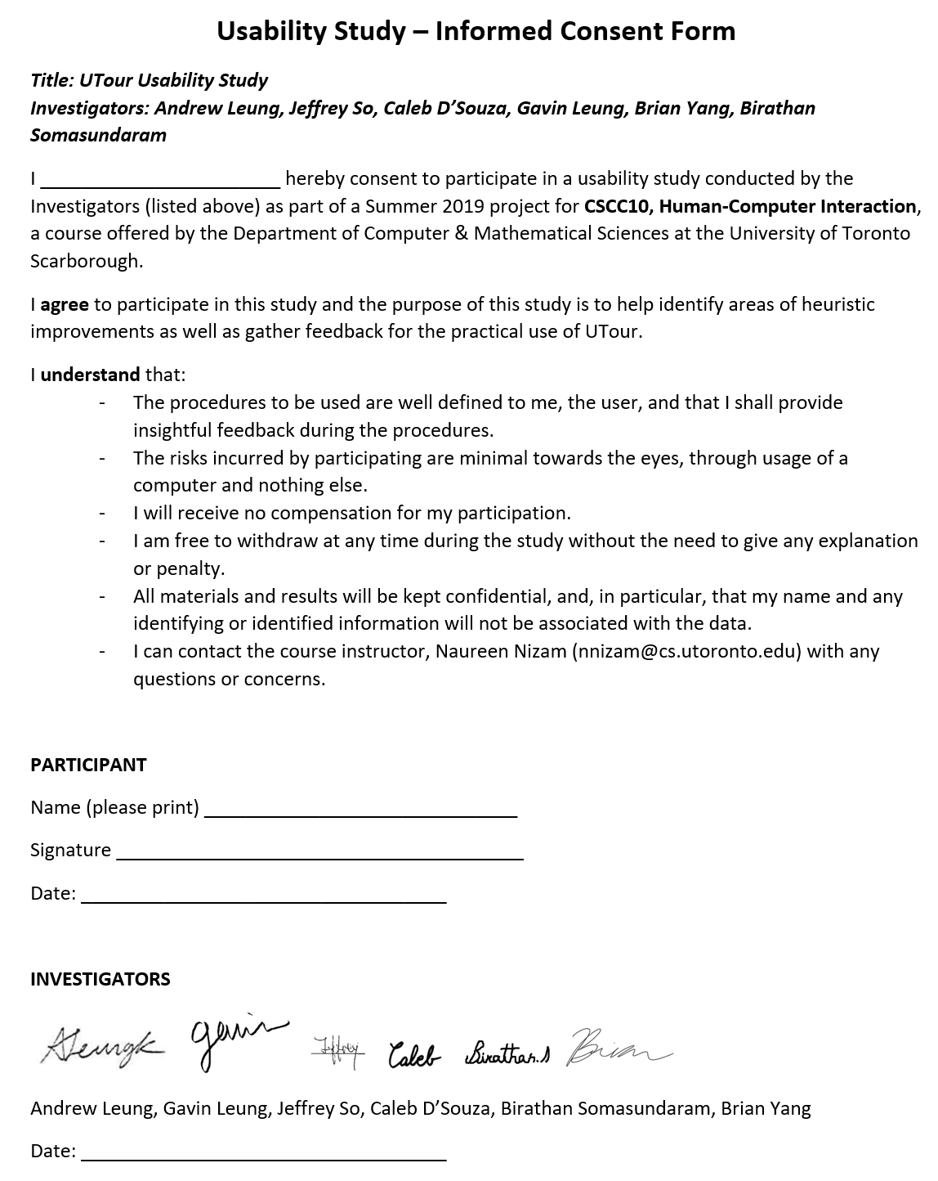

*Sample Interview Questions*

1. When adding a review, are there sufficient tools for you to properly convey your thoughts? (yes/no)
2. Would you consider the push notification on the lock screen a helpful feature? (helpful/not helpful)
3. When looking for an event to schedule, did you feel like you were given enough tools to find events? (yes/no)

*Raw Interview Notes*

